FARM MANAGEMENT SYSTEM

User Story:
In the Farm Management System (FMS), as a farmer, farm manager, or system administrator, I want to use a centralized Salesforce-based platform to record and manage farm, crop, farmer, and buyer information so that all agricultural data is stored securely and systematically. I want to enter and update farm details, crop production records, and buyer transactions easily through a user-friendly interface with proper validation rules to prevent incorrect entries. I also want the system to generate real-time reports and interactive dashboards so that I can analyze farm productivity, monitor sales, and make informed decisions. Additionally, I want role-based access and secure data storage to ensure that sensitive information is protected while enabling smooth collaboration among users. This system will help reduce manual paperwork, minimize errors, improve efficiency, and support data-driven farm management.

1. INTRODUCTION

1.1 Project Overview :

The Farm Management System (FMS) is a Salesforce-based application designed to digitize and streamline agricultural operations. It manages data related to farms, crops, farmers, and buyers while providing real-time insights through reports and dashboards. The system helps farmers and managers monitor agricultural activities efficiently and make informed decisions.

1.2 Purpose :

The main purpose of this project is to:

- Digitize agricultural data management
- Improve data accuracy and accessibility
- Automate record handling
- Enable real-time monitoring
- Support data-driven farming decisions
- Enhance productivity and transparency

2. IDEATION PHASE
2.1 Problem Statement (Customer Problem Statement Template)

PS | I am  (Customer) | I’m trying to | But | Because | Which makes me  feel
PS-1 | Farmer | Maintain farm and crop records | Data is often incomplete or incorrect | Records are kept manually in registers | Frustrated and confused
PS-2 | Farm Manager | Monitor farm productivity and sales | Reports are delayed and inaccurate | Data is scattered across files and sheets | Stressed and inefficient
PS-3 | Buyer | Access crop availability and pricing | Information is not updated regularly | There is no centralized digital system | Uncertain and dissatisfied
PS-4 | System Admin | Manage user access and system security | Unauthorize d access may occur | Access  control is handled manually | Concerned and insecure

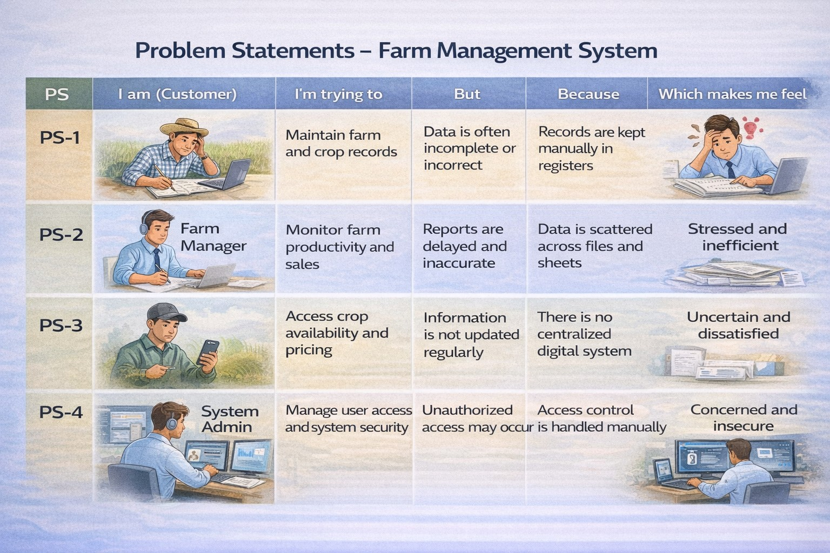

2.2 Empathy Map Canvas
Target Users:
- Farmers
- Farm Managers
- Buyers
- System Administrators

Empathy Analysis
- Think & Feel: Need accurate and timely farm data
- Hear: Feedback from agricultural officers
- See: Registers, paper files, spreadsheets
- Say & Do: Enter records manually
- Pain: Data loss, errors, delays
- Gain: Automation, fast reporting
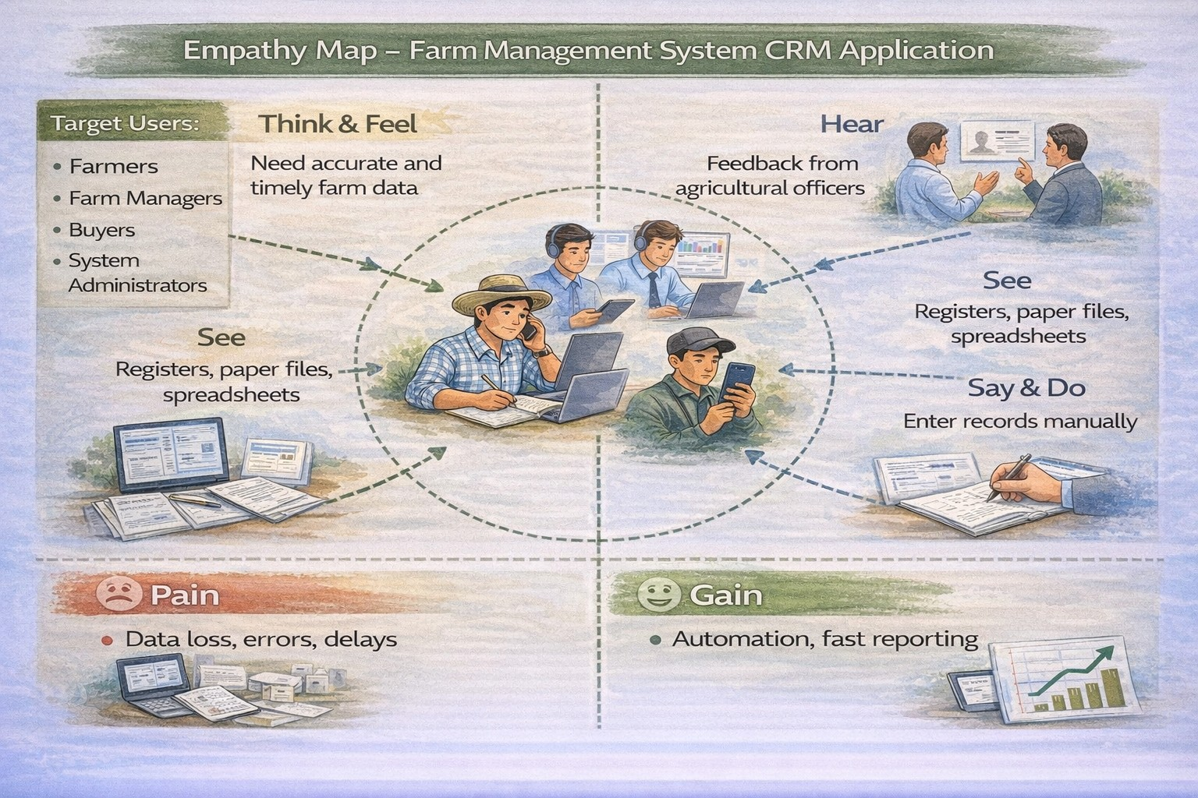

2.3 Brainstorming

Brainstormed Ideas
- Manual farm records
- Excel-based management
- Web-based system
- Mobile farm app
- Salesforce-based FMS

Selected Idea
Salesforce-based Farm Management System.

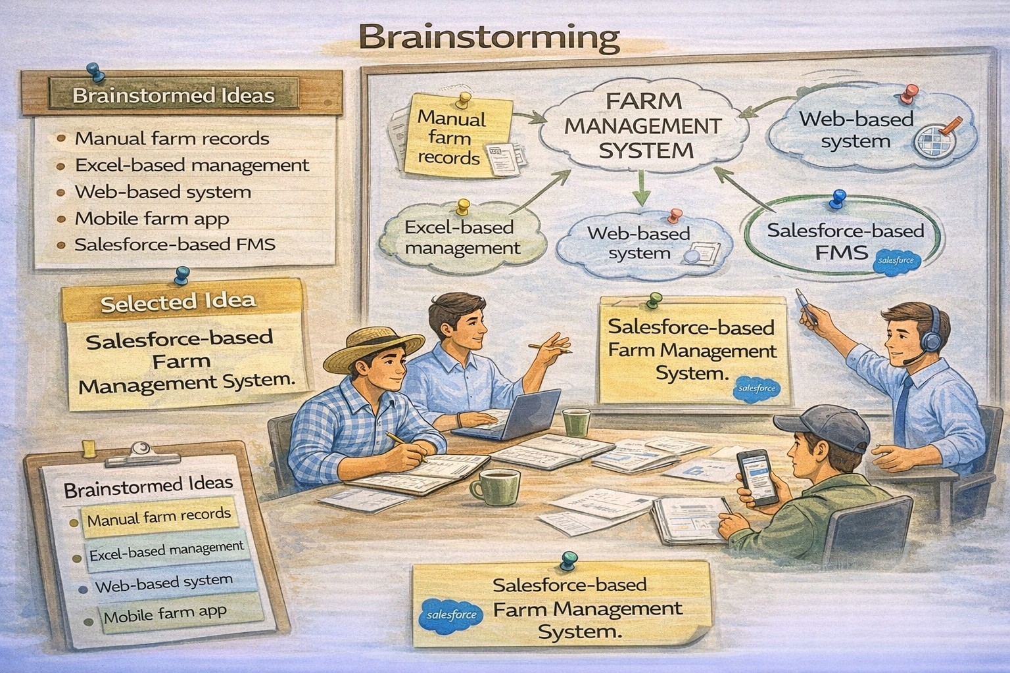

3.REQUIREMENT ANALYSIS PHASE

3.1 Customer Journey Map
Stages:
- Login
- Access Farm Management App
- Enter Farm and Crop Data
- Register Farmers and Buyers
- Generate Reports
- Analyze Results
- Decision Making

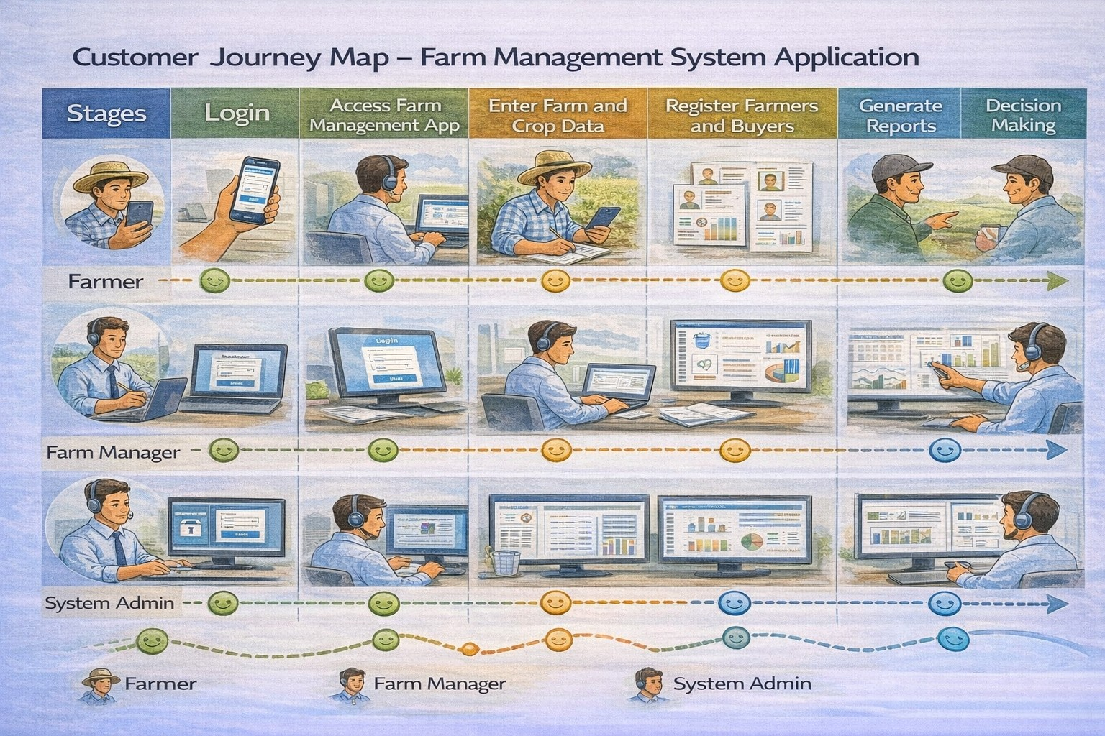

3.2 Solution Requirements

Functional Requirements

FR No | Requirement
FR-1 | User Authentication
FR-2 | Farm, Crop, Farmer, Buyer Management
FR-3 | Data Entry and Validation
FR-4 | Relationship Mapping
FR-5 | Report Generation
FR-6 | Dashboard Visualization
FR-7 | User Role Management

Non-Functional Requirements

NFR | Description | Example
Usability | Easy interface | Simple Lightning UI
Security | Data protection | Profiles & roles
Reliability | No data loss | Cloud backup
Performance | Fast access | Reports in <3 sec
Availability | 24/7 access | Cloud hosting
Scalability | Handles growth | More farms/users

3.3 Data Flow Diagram
Data Flow:
User → Salesforce UI → Custom Objects (Farm, Crop, Farmer, Buyer) → Validation
Rules → Relationships → Reports → Dashboards
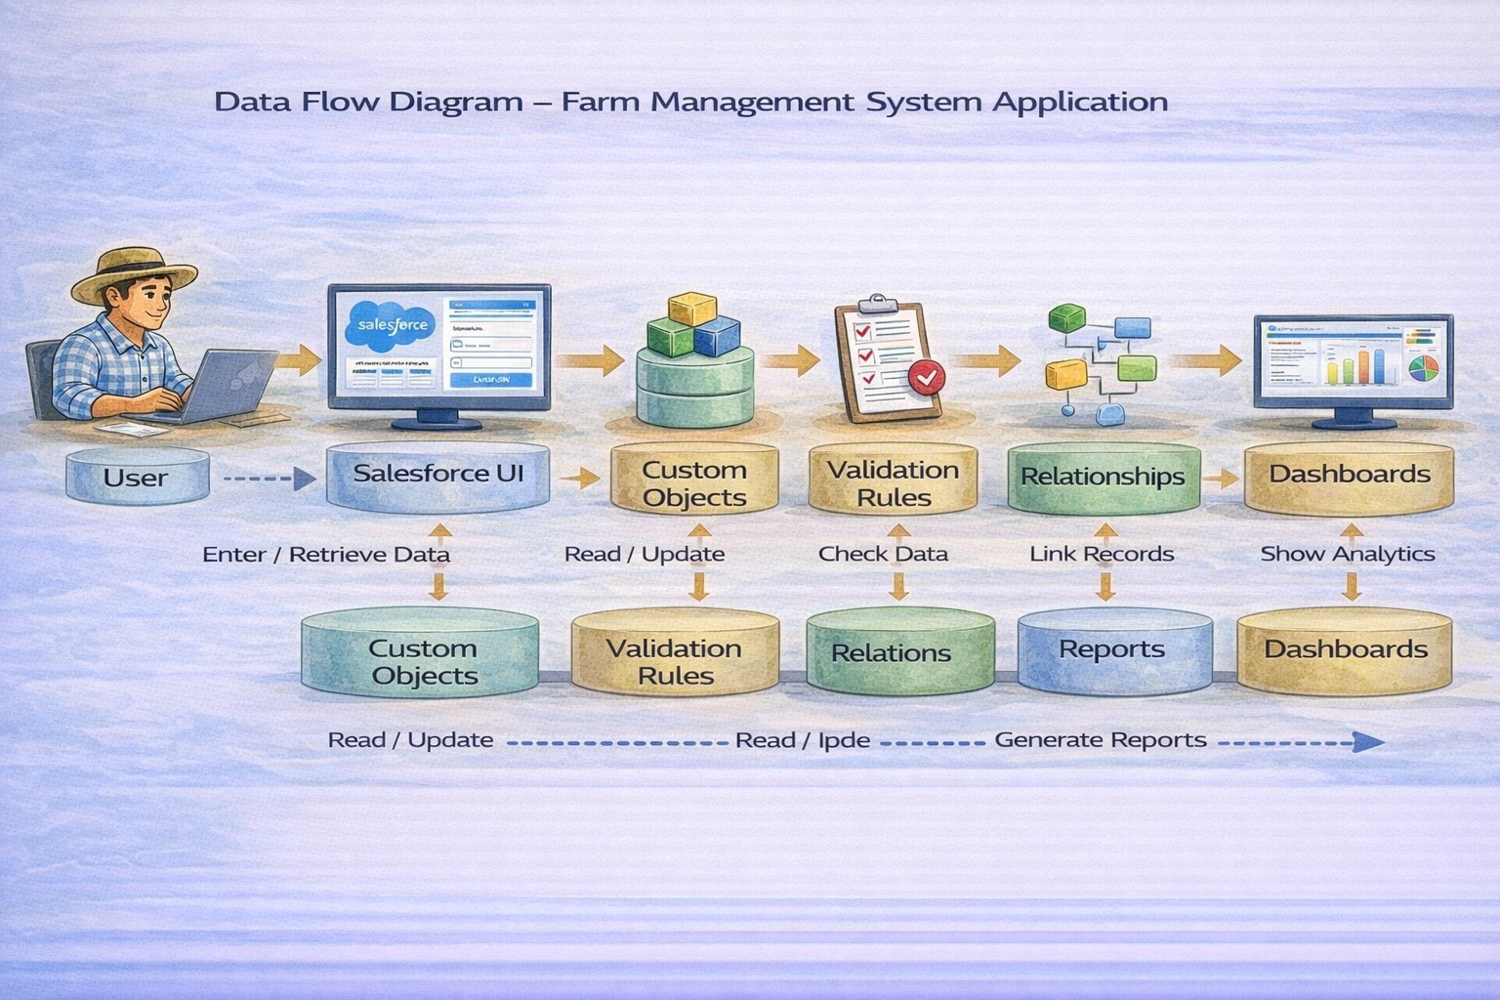

3.4 Technology Stack
Layer | Technology
Frontend | Salesforce Lightning UI
Backend | Salesforce Platform
Database | Salesforce Cloud
Automation | Validation Rules
Analytics | Reports & Dashboards

4. PROJECT DESIGN PHASE

4.1 Problem–Solution Fit
The FMS replaces manual farming records with automated data management. Cloud storage prevents data loss, dashboards improve analysis, and real-time reports eliminate delays. This ensures accurate and timely agricultural insights.
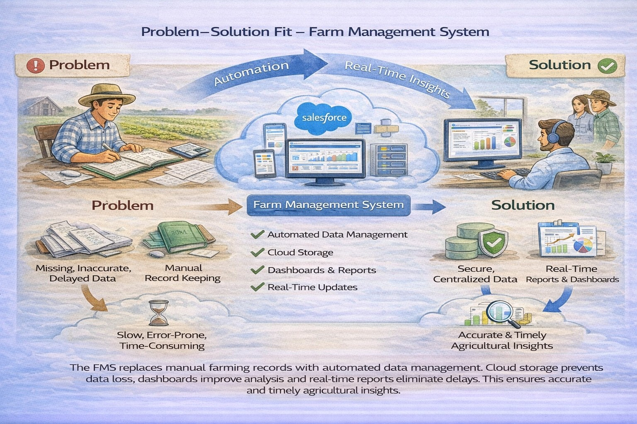

4.2 Proposed Solution

Functional Requirements
Parameter | Description
Problem | Manual maintenance of farm, crop, farmer, and buyer records leading to errors, data loss, and delays.
Solution | Salesforce-based Farm Management System with centralized data storage and automation.
Innovation | Automated data entry validation, cloud storage, and real-time reporting dashboards.
Impact | Improved data accuracy, faster reporting, and better decision-making for farmers and managers.es
Business Model | Digital farm management and agricultural data services platform.
Scalability | Supports multiple farms, users, and regions with cloud-based infrastructure.

4.3 Solution Architecture

Architecture Layers
- Presentation Layer – Salesforce Lightning UI
- Application Layer – Validation Rules, Relationships
- Data Layer – Custom Objects
- Analytics Layer – Reports and Dashboards

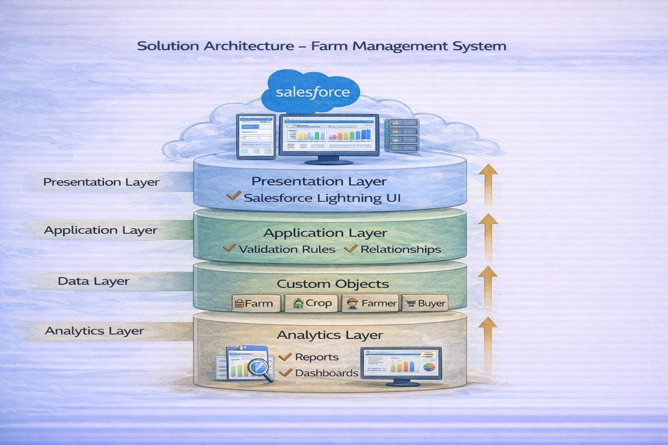

5. PROJECT PLANNING & SCHEDULING
5.1 Project Planning
- Created Salesforce Developer Org
- Developed custom objects
- Configured tabs and Lightning App
- Created fields and relationships
- Designed profiles and roles
- Created users and sharing rules
- Developed reports and dashboards
- Conducted testing and reviews

Product Backlog, Sprint Schedule, and Estimation (4 Marks)

Use the below template to create product backlog and sprint schedule

Sprint | Functional  Requirement  (Epic) | User  Story  Number | User Story / Task | Story Points | Priority | Team Member  s
Sprint-1 | Developer Setup | USN-1 | As a system administrator, I want to create and configure a  Salesforce developer account so that I can set up and deploy the Farm Management System. | 3 | High | Member1
Sprint-2a | Data Modeling | USN-2 | As an admin, I want to create Farm, Crop, Farmer, and Buyer objects with proper relationships so that agricultural data is stored and managed efficiently. | 5 | High | Member2
Sprint-2 | Data Modeling | USN-3 | As a staff member, I want tabs and a Lightning App for all farm modules so that I can easily navigate and perform daily operations. | 5 | High | Member3
Sprint-3 | Automation | USN-4 | As a system, I want to validate farm and crop details such as dates, quantities, and mandatory fields so that incorrect or incomplete records are prevented. | 3 | High | Member4
Sprint-3 | Automation | USN-5 | As a manager, I want automated flows for crop updates and buyer notifications so that farm operations are processed faster without manual intervention. | 3 | High | Member4
Sprint-4 | Security | USN-6 | As an administrator, I want role-based access control for farmers, managers, and buyers so that sensitive farm and transaction data is secure. | 5 | High | Member2
Sprint-5 | Reports | USN-7 | As a farm manager, I want reports showing crop yield, sales, and buyer transactions so that I can monitor farm performance and make informed decisions. | 4 | High | Member3
Sprint-6 | Dashboards | USN-8 | As a farm manager, I want dashboards showing crop productivity, sales trends, and operational statistics so that I can monitor performance visually. | 4 | Medium | Member4

Project Tracker, Velocity & Burndown Chart: (4 Marks)
Sprint | Total Story Points | Duratio n | Sprint Start Date | Sprint End Date (Planned) | Story Points  Completed  (as on  Planned End  Date) | Sprint Release Date (Actual)
Sprint-1 | 20 | 6 Days | 24 Oct 2022 | 29 Oct 2022 | 20 | 29 Oct 2022
Sprint-2 | 20 | 6 Days | 31 Oct 2022 | 05 Nov 2022
Sprint-3 | 20 | 6 Days | 07 Nov 2022 | 12 Nov 2022
Sprint-4 | 20 | 6 Days | 14 Nov 2022 | 19 Nov 2022

6. PROJECT DEVELOPMENT PHASE

Project Description:
The Farm Management System (FMS) in Salesforce is a comprehensive solution designed to digitize and streamline agricultural operations. This application empowers farmers, farm managers, and stakeholders by managing data related to crops, Farm, Farmer, and buyers, while providing actionable insights through reports and dashboards.

Milestone 1 – Salesforce

What Is Salesforce?
Salesforce is your customer success platform, designed to help you sell, service, market, analyze, and connect with your customers. Salesforce provides standard products and features to manage relationships with prospects and customers, collaborate with employees and partners, and store data securely in the cloud.

Activity 1: Creating a Salesforce Developer Org

- Search Developer.salesforce.com/signup.
- Enter First name, Last name, Email, Role, Company, Country/Region, Postal code, and a unique Username.
- Click Sign Me Up. After receiving the Salesforce email, verify the account and create a new password.
- Click Save.
- Search login.salesforce.com.
- Use the username and password to log in to the Salesforce org.
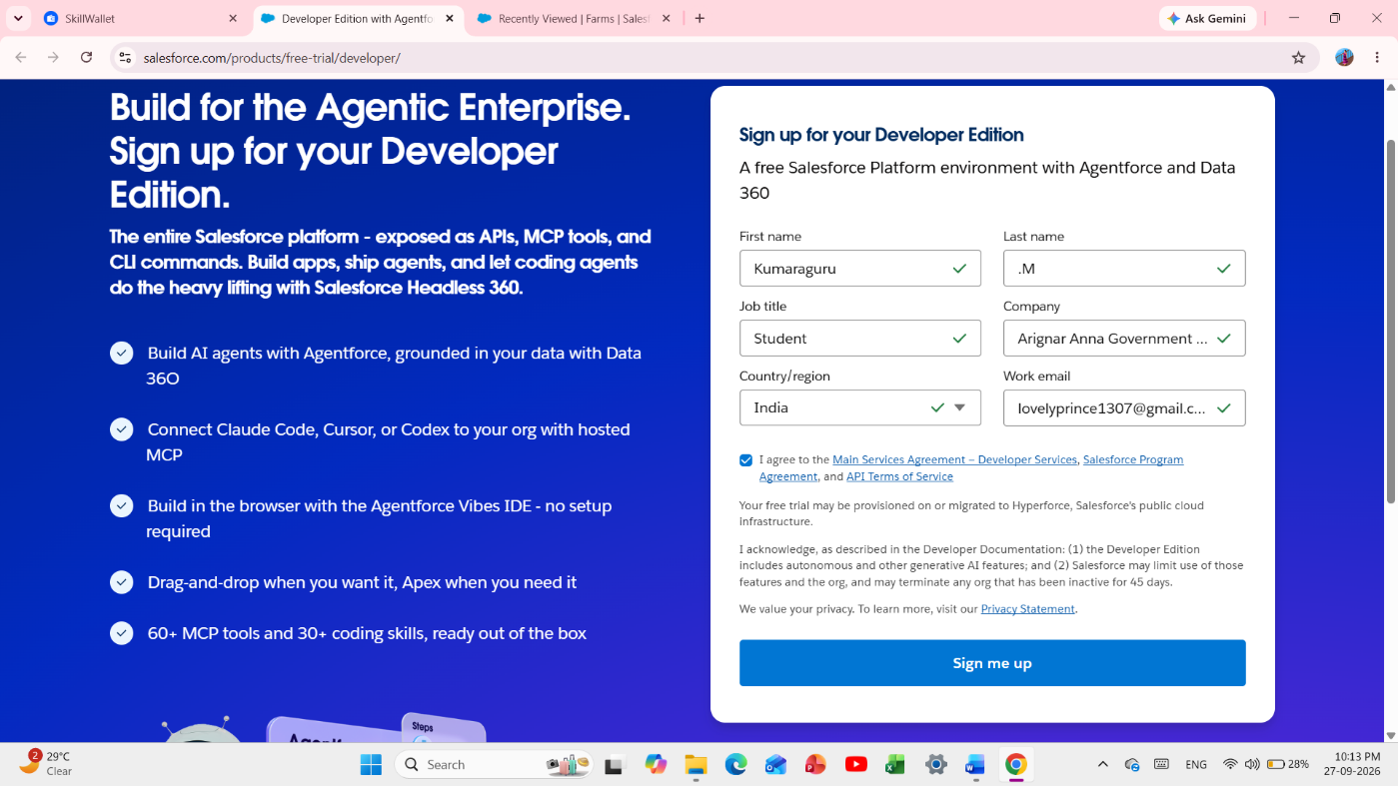

Fig 1 - Salesforce Org Homepage

Milestone 2 – Object

Salesforce objects are database tables that permit you to store data that is specific to an organization. They consist of fields (columns) and records (rows).
In this application we use four custom objects:
1. Farm
2. Crop
3. Farmer
4. Buyer

Activity 1: Create a custom object for Farm

- From Setup, click Object Manager. Click Create and select Custom Object.
- Fill Label as "Farm", Plural Label as "Farms", Record Name as "Farm Name", and select Text as the data type.
- Under Optional Features, select Allow Reports and Track Field History.
- Under Deployment Status, ensure Deployed is selected.
- Under Search Status, select Allow Search.
- Under Object Creation Options, select Add Notes and Attachments related list to default page layout.
- Leave other settings as default and click Save.

Activity 2: Creation of Crop object

- Click the gear icon, select Setup, and open Object Manager.
- Click Create and select Custom Object.
- Set Label to "Crop", Plural Label to "Crops", Record Name to "Crop Name", and data type to Text.
- Select Allow Reports and Allow Search.
- Select Add Notes and Attachments related list to default page layout and click Save.

Activity 3: Creation of Farmer object

- Open Setup and Object Manager, then select Create > Custom Object.
- Set Label to "Farmer", Plural Label to "Farmers", Record Name to "Farmer Name", and data type to Text.
- Select Allow Reports and Allow Search.
- Select Add Notes and Attachments related list to default page layout and click Save.

Activity 4: Creation of Buyer object

- Open Setup and Object Manager, then select Create > Custom Object.
- Set Label to "Buyer", Plural Label to "Buyers", Record Name to "Buyer Name", and data type to Text.
- Select Allow Reports and Allow Search.
- Select Add Notes and Attachments related list to default page layout and click Save.

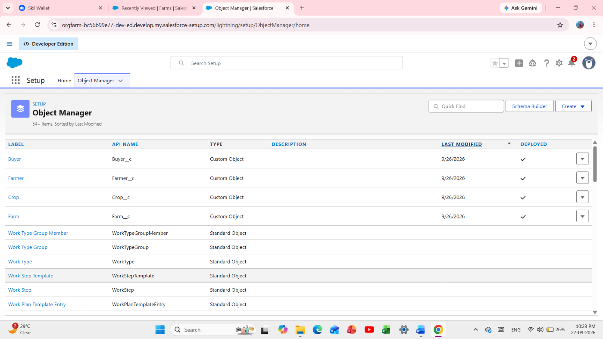

Fig 2 - Object Manager - 4 Objects List

Milestone 3 - Tab
Tabs in Salesforce help users view information at a glance. They display data of objects and other web content in the application.

Activity: Creation of Farm tab

- Click Home, enter Tabs in Quick Find, and select Tabs.
- Under Custom Object Tabs, click New.
- For Object, select Farm.
- For Tab Style, select any icon.
- Leave defaults as they are. Click Next, Next, and Save.

Activity: Creation of Crop tab

- Click Home, enter Tabs in Quick Find, and select Tabs.
- Under Custom Object Tabs, click New.
- For Object, select Crop.
- For Tab Style, select any icon.
- Leave defaults as they are. Click Next, Next, and Save.

Activity: Creation of Farmer tab

- Click Home, enter Tabs in Quick Find, and select Tabs.
- Under Custom Object Tabs, click New.
- For Object, select Farmer.
- For Tab Style, select any icon.
- Leave defaults as they are. Click Next, Next, and Save.

Activity: Creation of Buyer tab

- Click Home, enter Tabs in Quick Find, and select Tabs.
- Under Custom Object Tabs, click New.
- For Object, select Buyer.
- For Tab Style, select any icon.
- Leave defaults as they are. Click Next, Next, and Save.

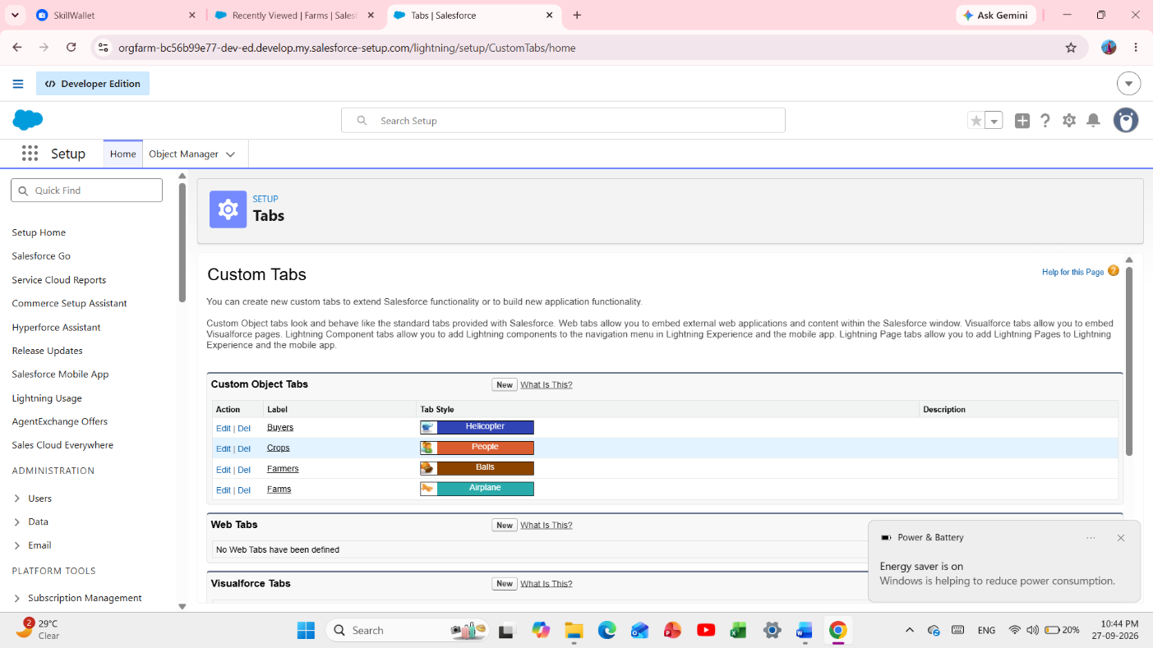

Fig 3 - Tabs List - 4 Custom Tabs

Milestone 4 - Lightning App
An App in Salesforce is a group of tabs that help the application function by working together as a unit. It has a name, a logo, and a particular set of tabs.

Activity 1: Create the Farm Management System app
- From Setup, enter App Manager in Quick Find and select App Manager.
- Click New Lightning App. Enter Farm Management System as the App Name and click Next.
- Under App Options, leave default selections and click Next.
- Under Utility Items, leave as is and click Next.
- From Available Items, select Farm, Crop, Farmer, Buyer, Reports, and Dashboards and move them to Selected Items. Click Next.
- From Available Profiles, select System Administrator and move it to Selected Profiles. Click Save & Finish.
- Verify the app from App Launcher by searching for Farm Management System.

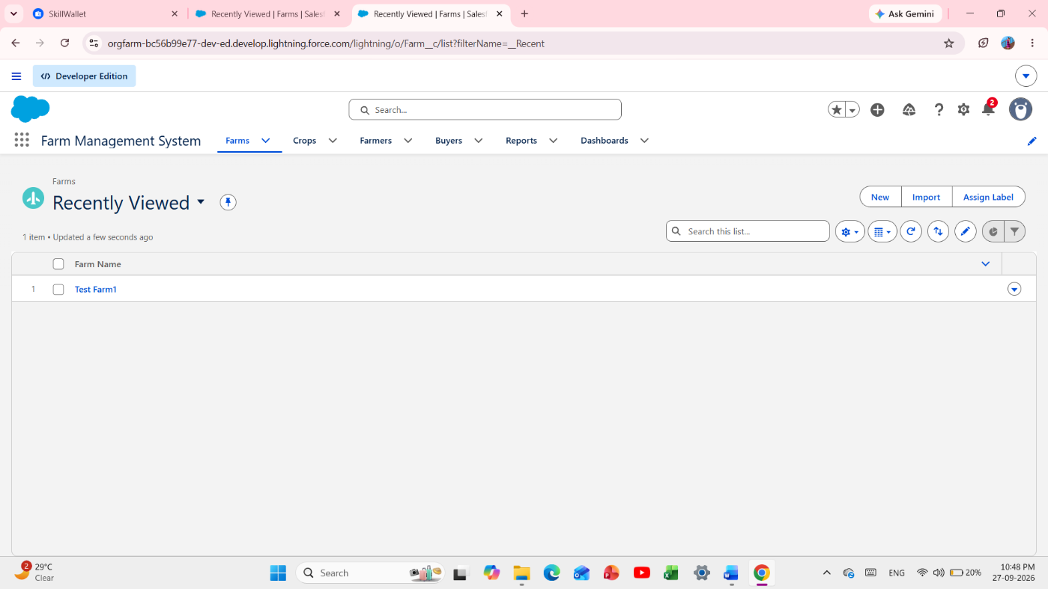

Fig 4 - Lightning App - Farm Management System

Milestone 5 - Fields and Relationships
Fields in Salesforce represent what columns represent in relational databases. They store data values required for a particular object record.

Activity 1: Creation of fields for the Farm object
- Open Setup > Object Manager > Farm > Fields & Relationships and click New.
- Choose Picklist, click Next, set Field Label to Farm Type, and values to Crop, Livestock, Mixed. Save.
- Create a Picklist field named Soil Quality with values Organic, Cover Crops, Composting.
- Create a Picklist field named Irrigation Type with values Sprinkler irrigation, Drip irrigation, Localized irrigation.
- Create Text fields named Location and Size.
- Create a Master-Detail Relationship with the Farmer object.

Activity 2: Creation of fields for the Crop object

- Create a Text field named Crop Name.
- Create Date fields named Planting Date and Harvest Date.
- Create a Lookup Relationship on Crop related to Farm.
- Create a Currency field named Actual Yield.
- Create a Number field named Total Acres Harvested with maximum length 20.
- Create a Formula field named Expected Yield per Acre with Currency return type.
- Use the formula Actual Yield divided by Total Acres Harvested.

Activity 3: Creation of fields for the Farmer object

- Create a Phone field named Contact Number.
- Create a Picklist field named State with values Telangana, Andhra Pradesh, Tamilnadu.
- Create a Picklist field named District and enter appropriate district values.
- Create a Picklist field named Village and enter appropriate village values.
- Create a field dependency with State as the controlling field and District as the dependent field.
- Select the appropriate dependent values for each state, preview the dependency, and save.

Activity 4: Creation of fields for the Buyer object

- Create a Phone field named Contact.
- Create an Email field named Email.
- Create a Text Area field named Address.
- Create a Picklist field named Buyer Type with values Wholesale and Retail.

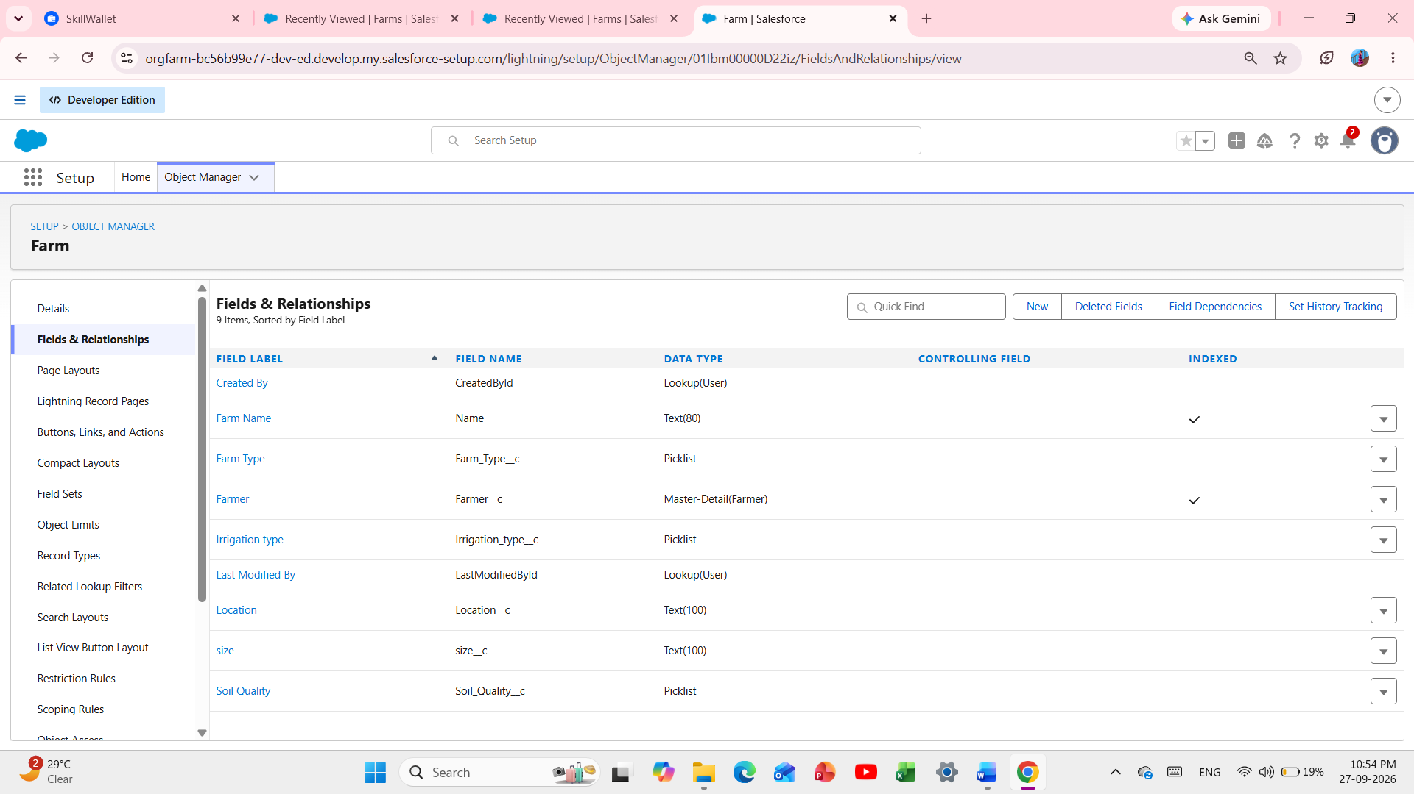

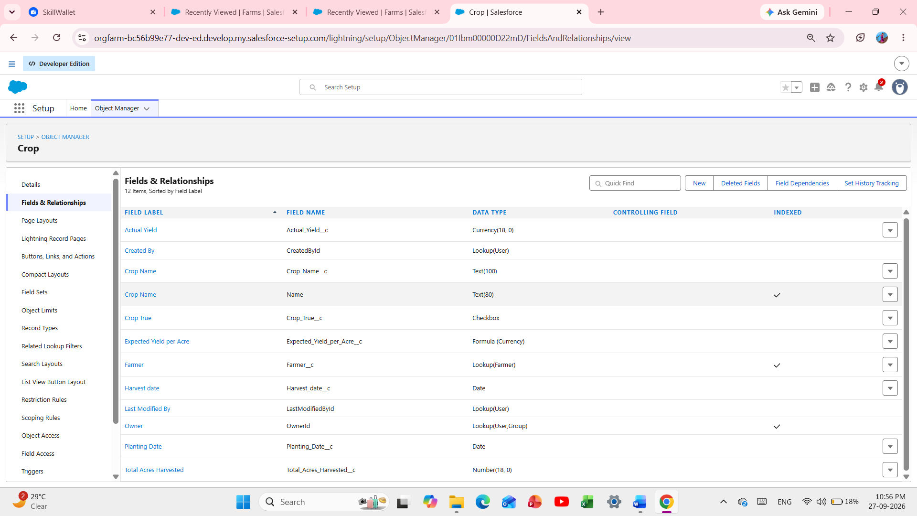

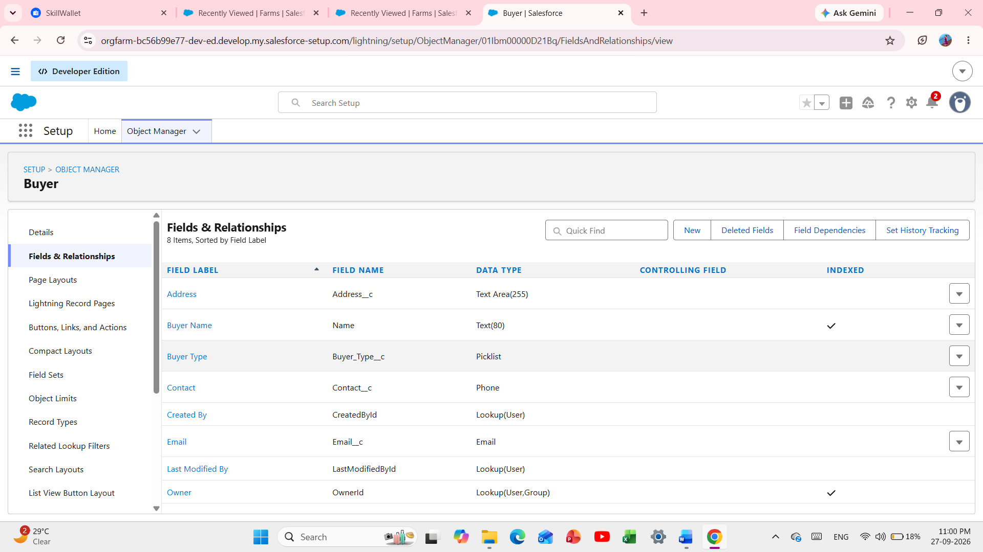

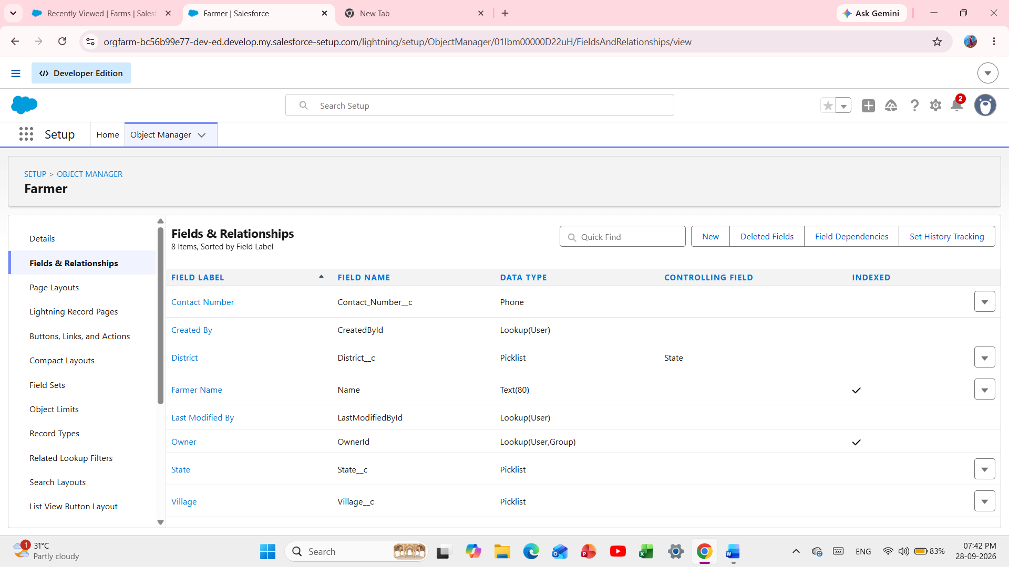

Fig 5 - Fields & Relationships - Farm/Crop/Buyer/Farmer

Milestone 6 - Profile
A profile is a collection of settings and permissions that define what a user can do in Salesforce. It controls object permissions, field permissions, user permissions, tab settings, app settings, Apex class access, Visualforce page access, page layouts, record types, login hours, and login IP ranges. A profile can be assigned to many users, but each user can have only one profile at a time.

Activity 1: Create a custom profile

- From Setup, enter Profiles in Quick Find and select Profiles.
- Select Standard User and click Clone.
- Enter Sales Department as the profile name and click Save.

Activity 2: Create a custom profile - Farm Manager

- From Setup, enter Profiles in Quick Find and select Profiles.
- Select Standard User and click Clone.
- Enter Farm Manager as the profile name and save.

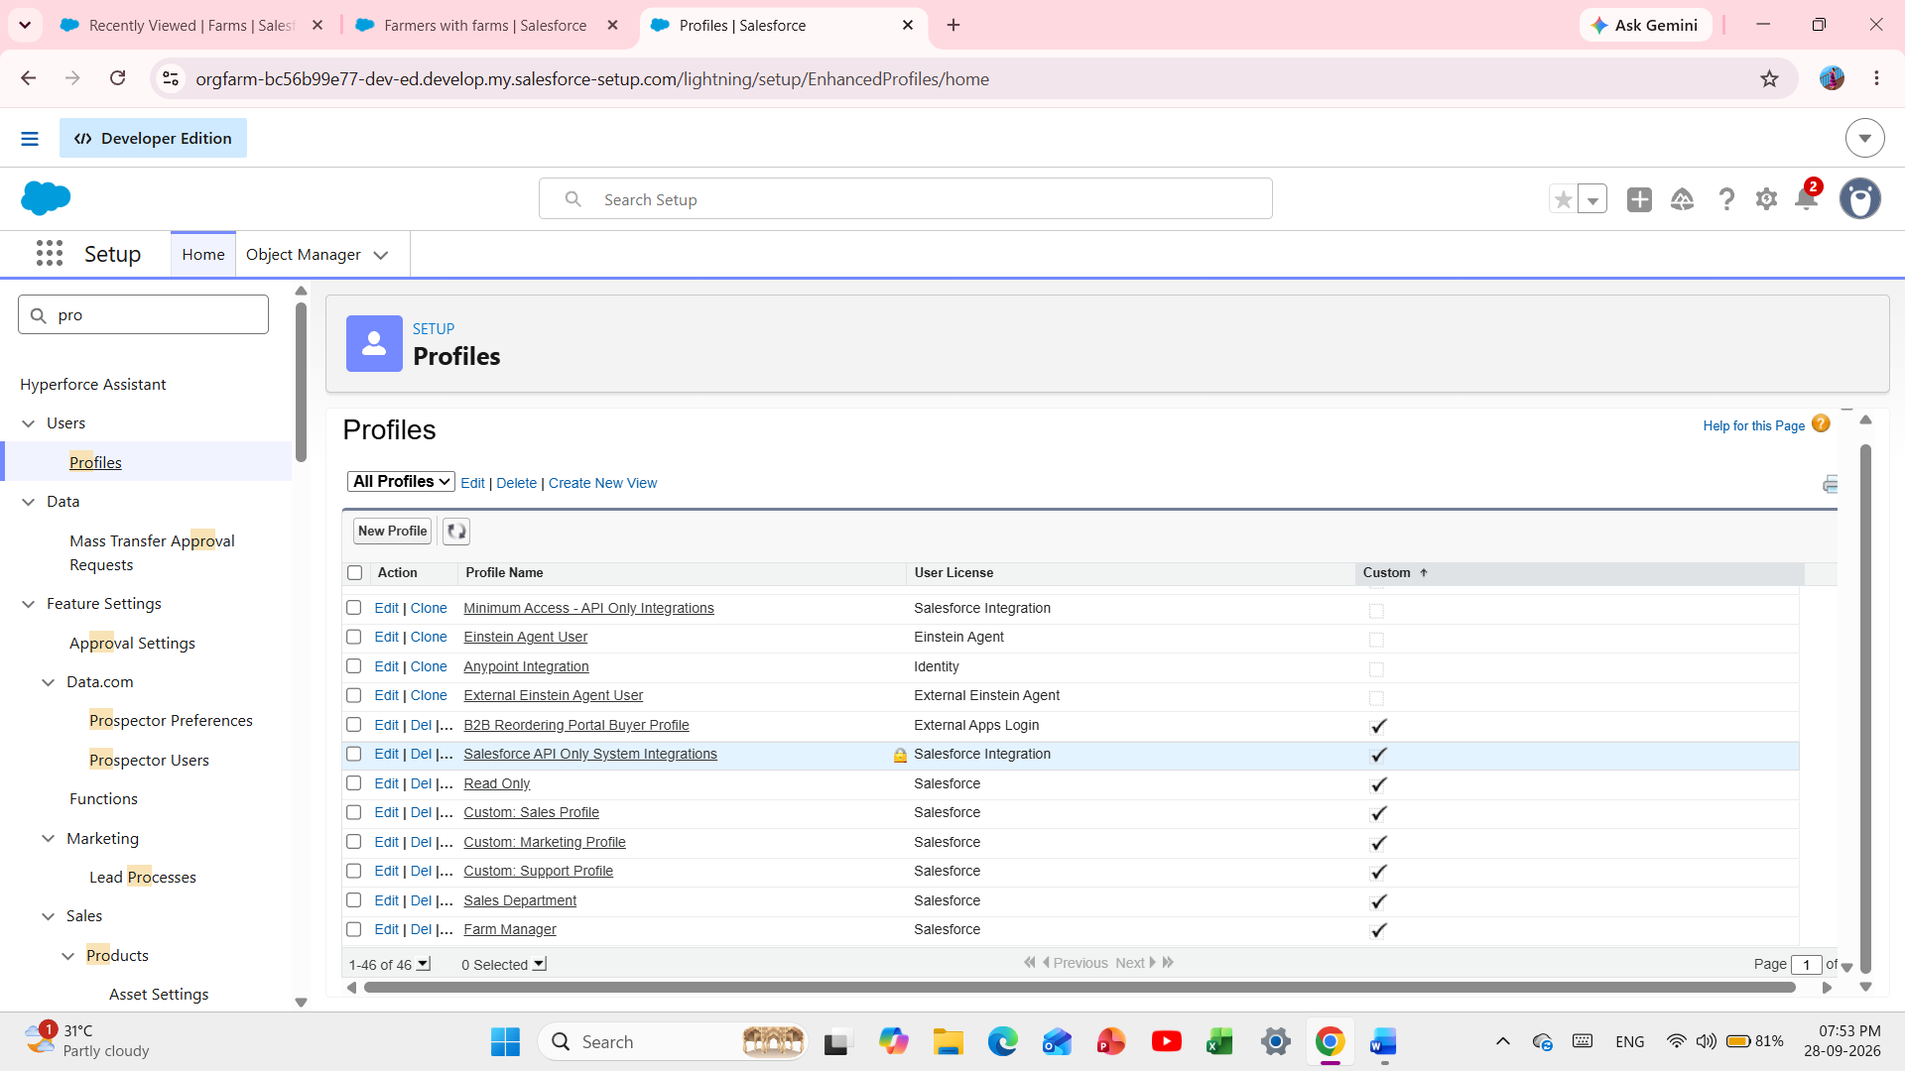

Fig 7 - Profiles List - Sales & Farm Manager

Milestone 7 - Role
In Salesforce, roles determine data access and define the reporting hierarchy within an organization.

Activity 1: Creation of role

- From Quick Find, search for Roles and select Roles.
- Select Set Up Roles.
- Below CEO, click Add Role.
- Enter the label "Farm Manager". The role name will be automatically populated, then click Save.
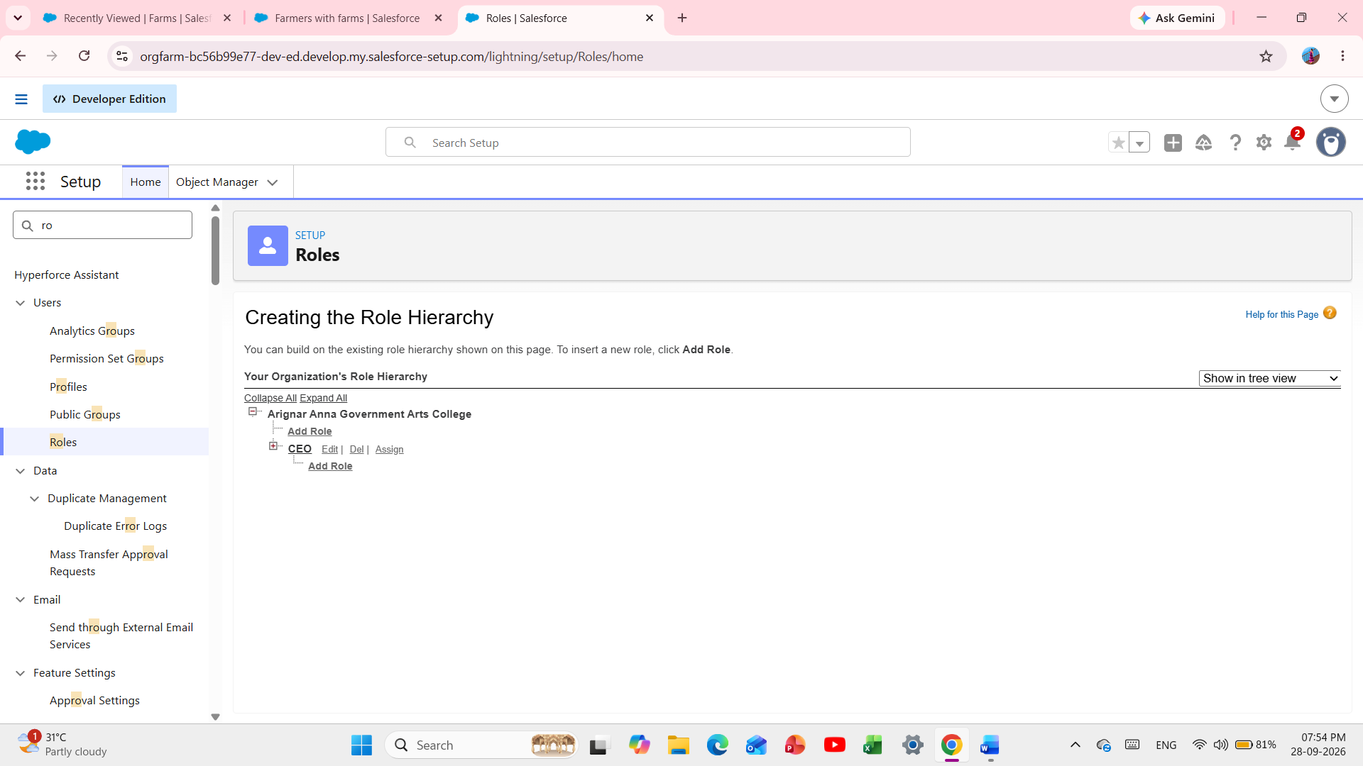

Fig 8 - Roles Hierarchy - Farm Manager

Milestone 8 - User
A user is anyone who logs into Salesforce. Users can be employees such as sales representatives, managers, and IT specialists who need access to company records. Each user has a user account that determines the features and records they can access.
Note: As a Salesforce Developer Org has limited Salesforce licenses, deactivate an existing user or change the license type if a required license is unavailable.

Activity 1: To Create a user

- From Setup, enter Users in Quick Find and select Users. Click New User.
- Enter First Name as Farm and Last Name as Manager.
- Enter the user's name, email address, and a unique username in email format.
- Select the Farm Manager role.
- Select User License as Standard Platform User.
- Select the Farm Manager profile and click Save.

Activity 2: Create Sales Department user

- Create a user with username as Sales Department and assign the Sales Manager profile. Follow the steps from Activity 1.

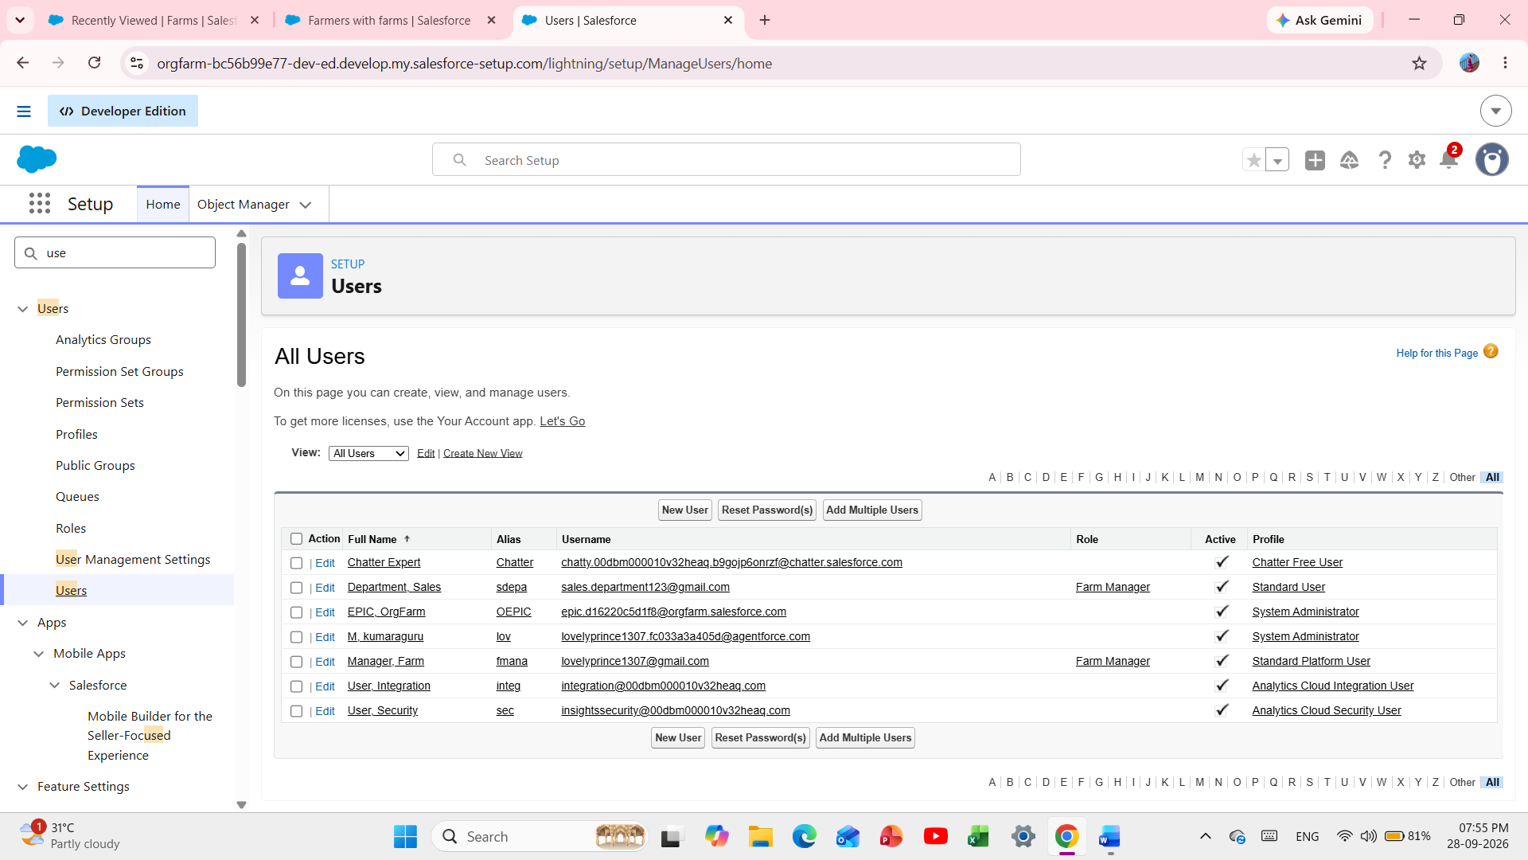
Fig 9 - Users List - Farm Manager & Sales Department

Milestone 9 - Sharing Rules
Sharing rules help users share records based on conditions. They are mainly used for objects whose Organization-Wide Defaults are Public Read Only or Private because sharing rules extend access rather than restrict it.
Types of Sharing Rules: Owner-based Sharing Rules and Criteria-based Sharing Rules.

Activity 1: Create a sharing rule

- Go to Sharing Settings from Quick Find.
- Scroll to the required object and click New to create a sharing rule.
- Enter the label of the sharing rule.
- Select the required rule type based on criteria.
- Select the required Crop field and criteria.
- Set Crop equal to True where applicable.
- Under users to share with, select Roles and Farm Manager.
- Set access level to Read/Write and save the rule.

Activity 2: Buyer sharing rule

- Create a sharing rule to share Buyer records with the Sales Department with Read/Write access. Follow the steps from Activity 1.

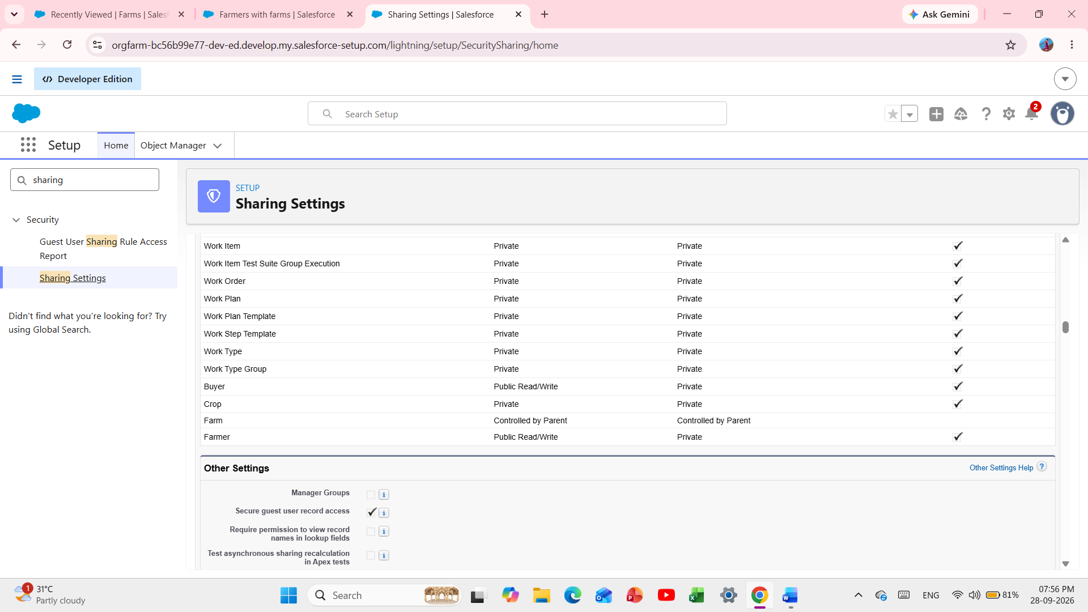

Fig 10 - Sharing Rules - Crop & Buyer

Milestone 10 - User Adoption

Activity 1: Create a Record (Farmer)
- Click App Launcher on the left side of the screen.
- Search Farm Management System and open it.
- Click the Farmer tab.
- Click New, fill in the details, and click Save.

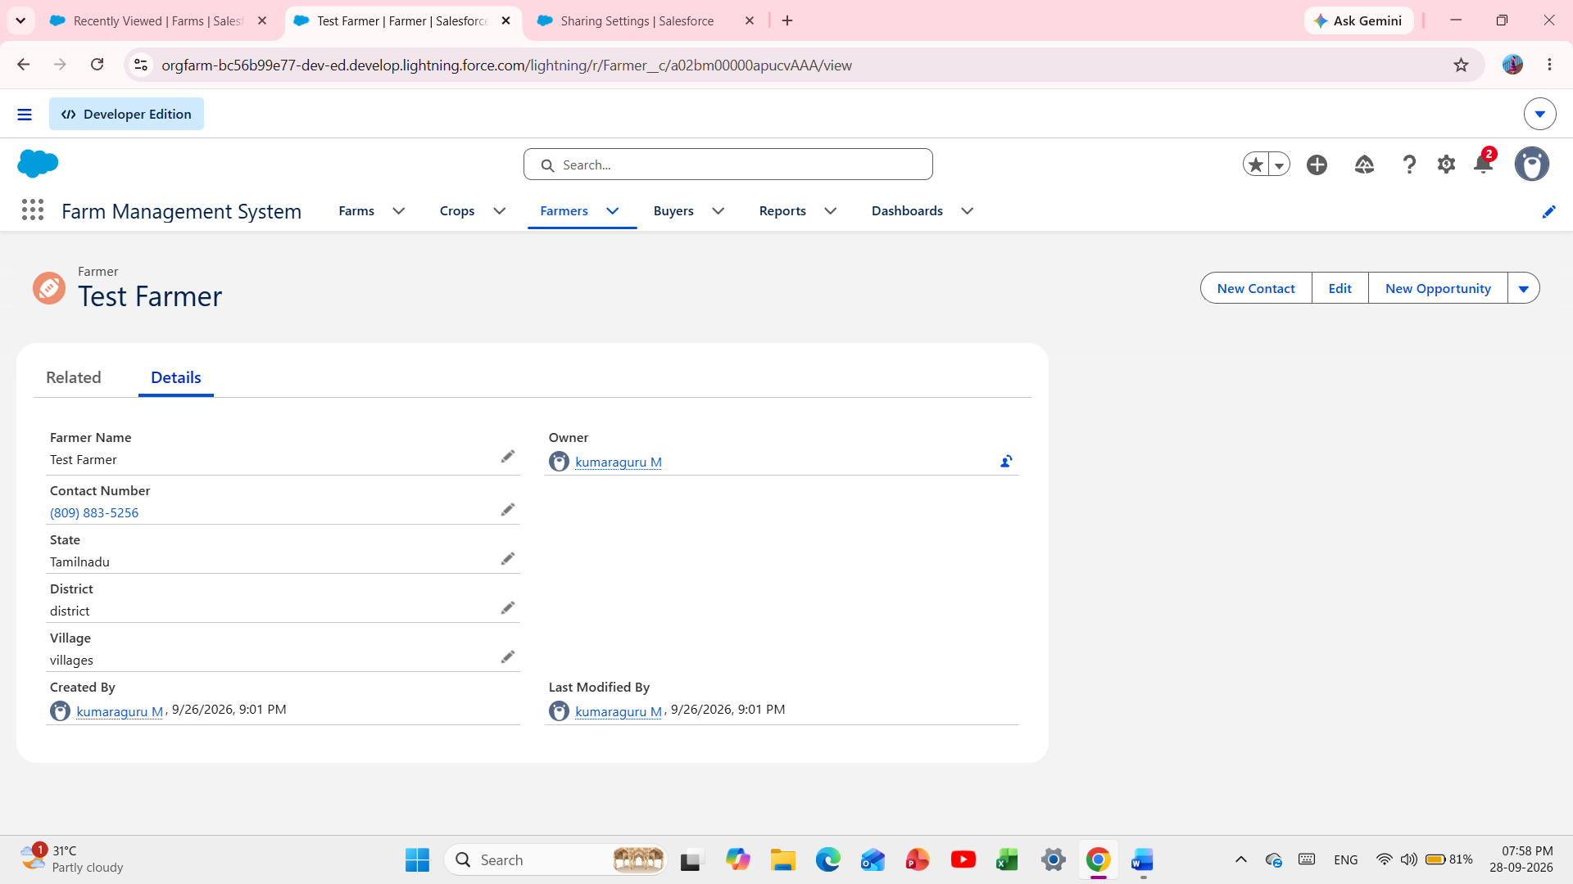

Fig 11 - Farmer Record Creation

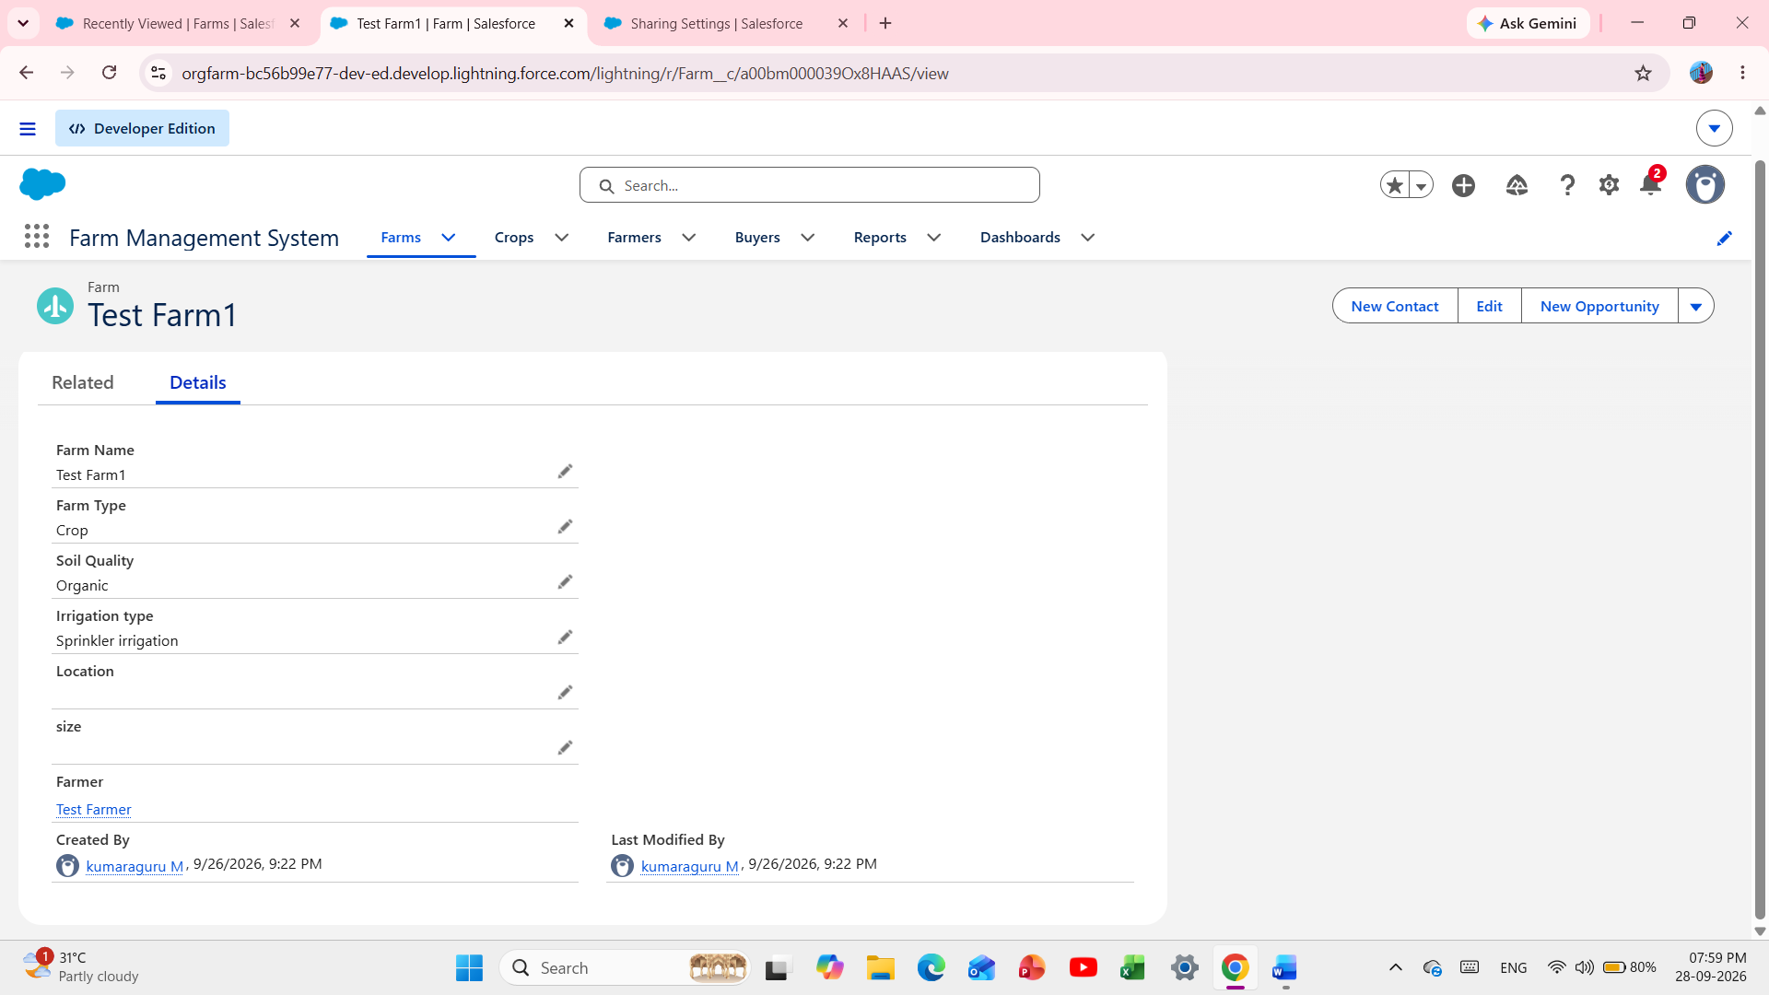

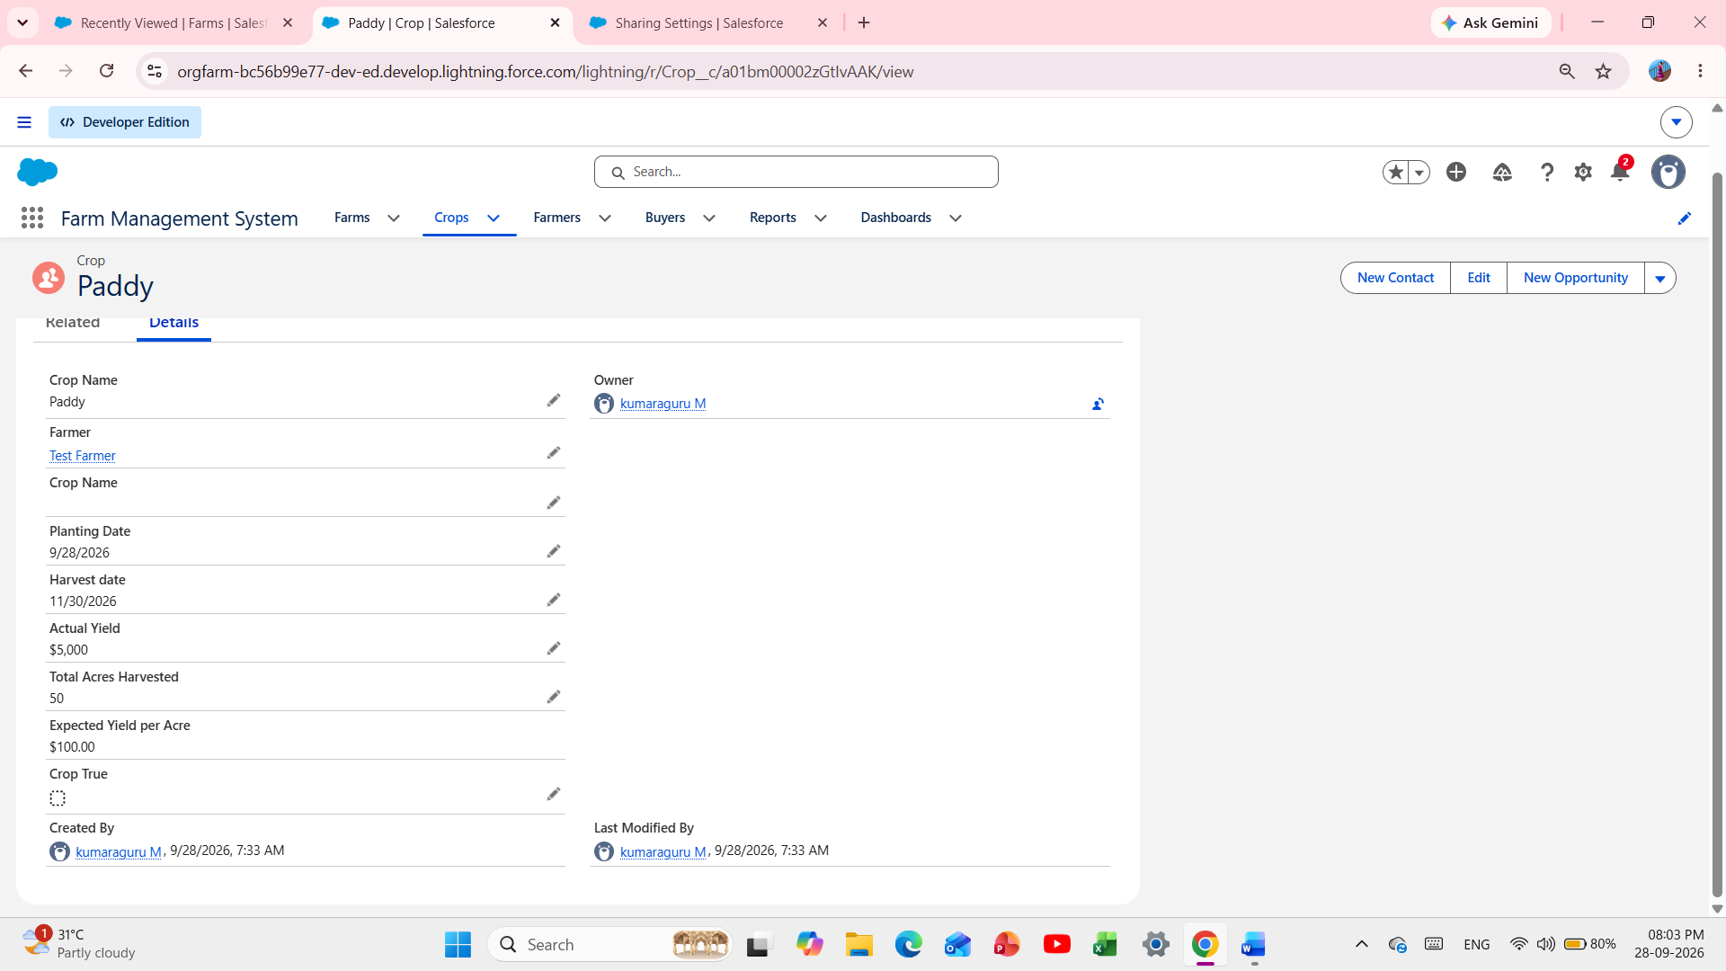

Fig 12 - Farm / Crop Record Creation

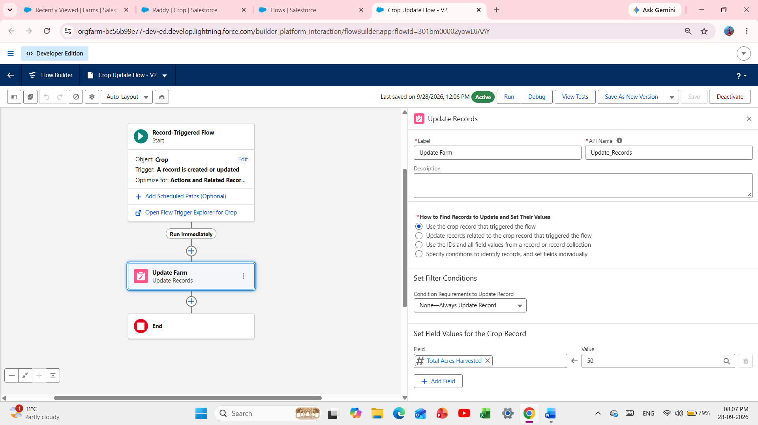

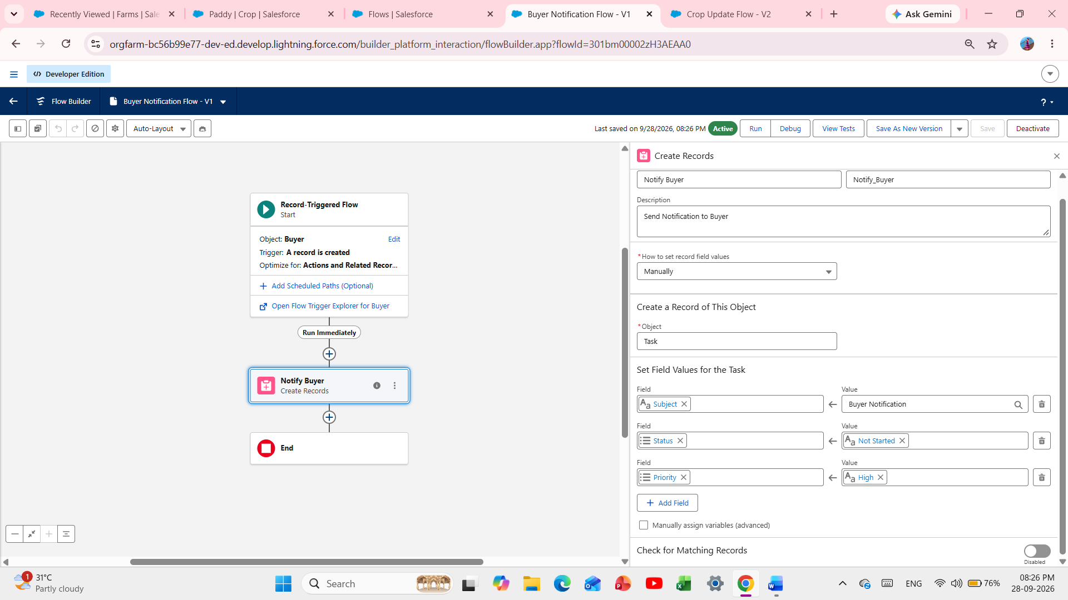

Fig 13 - Flows List - 2 Active Flows

Milestone 11 - Reports
A report is a list of records that meet defined criteria. It is displayed in rows and columns and can be filtered, grouped, or displayed using graphical charts. Reports are stored in folders that can be public, hidden, or shared.

Activity 1: Create a report

- Open App Launcher and search for Reports.
- Click New Report and select the required report type such as Farmer with Farms.
- Click Start Report.
- In Outline, select the columns/fields to display.
- Use Group to select fields for grouping.
- Save the report with the label Farmer with Farms and save it in a public folder.

Activity 2: Create a Crop and Buyer report

- Create a report using the Crop and Buyer objects by following the same report creation steps.

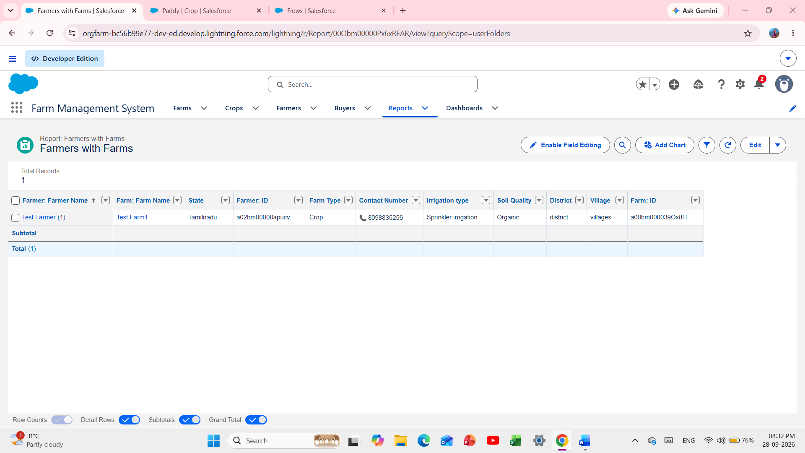

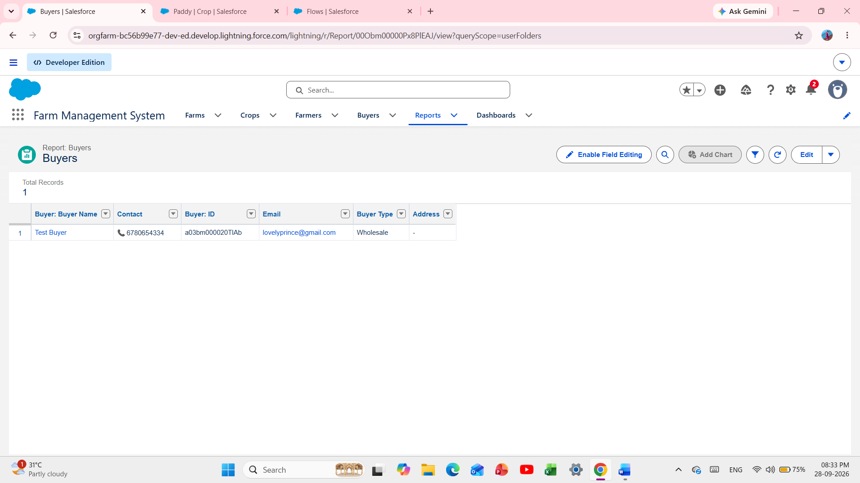

Fig 14 – Reports Tab – 3 Reports List

Milestone 12 – Dashboard
Dashboards provide more insights than reports by combining data from multiple reports and presenting summarized results. Dashboards can contain charts, graphs, and tabular data.

Activity 1: Create a Dashboard

- Click the Dashboard tab.
- Click New Dashboard.
- Name the dashboard Farmers with Farms and click Create.
- Click + Component.
- Select the Farmers with Farms report and click Select.
- Select the Gauge chart and click Add.
- Click Save and then Done.

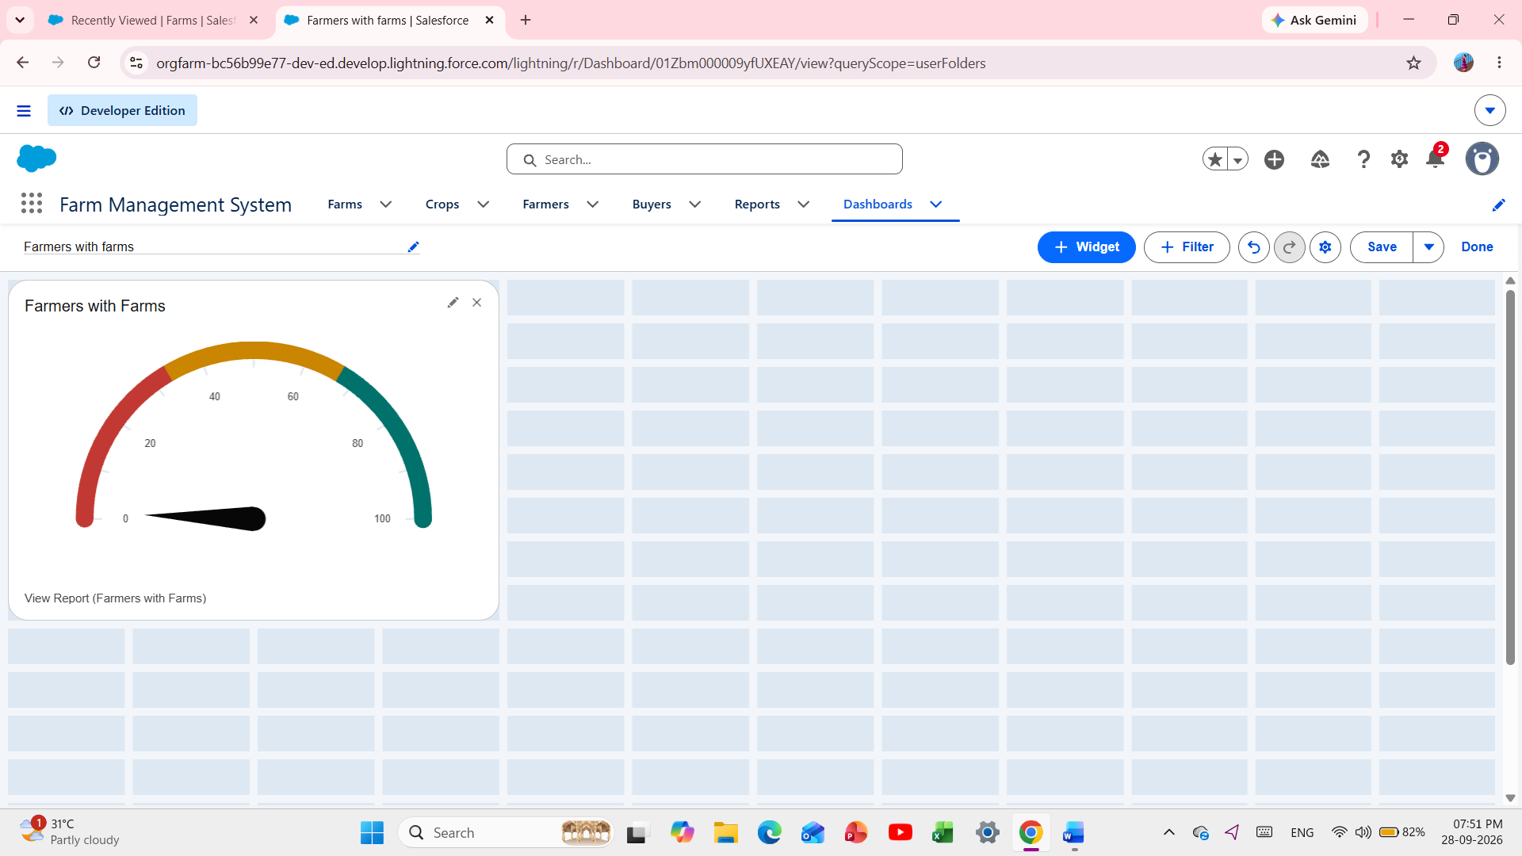

Fig 15 - Dashboard View - Gauge Chart

Milestone 13 - View Report and Dashboard

Activity 1: Report
- Click App Launcher on the left side of the screen.
- Search Farm Management System and open it.
- Click the Reports tab.
- Click Farmers with Farms and view the records.

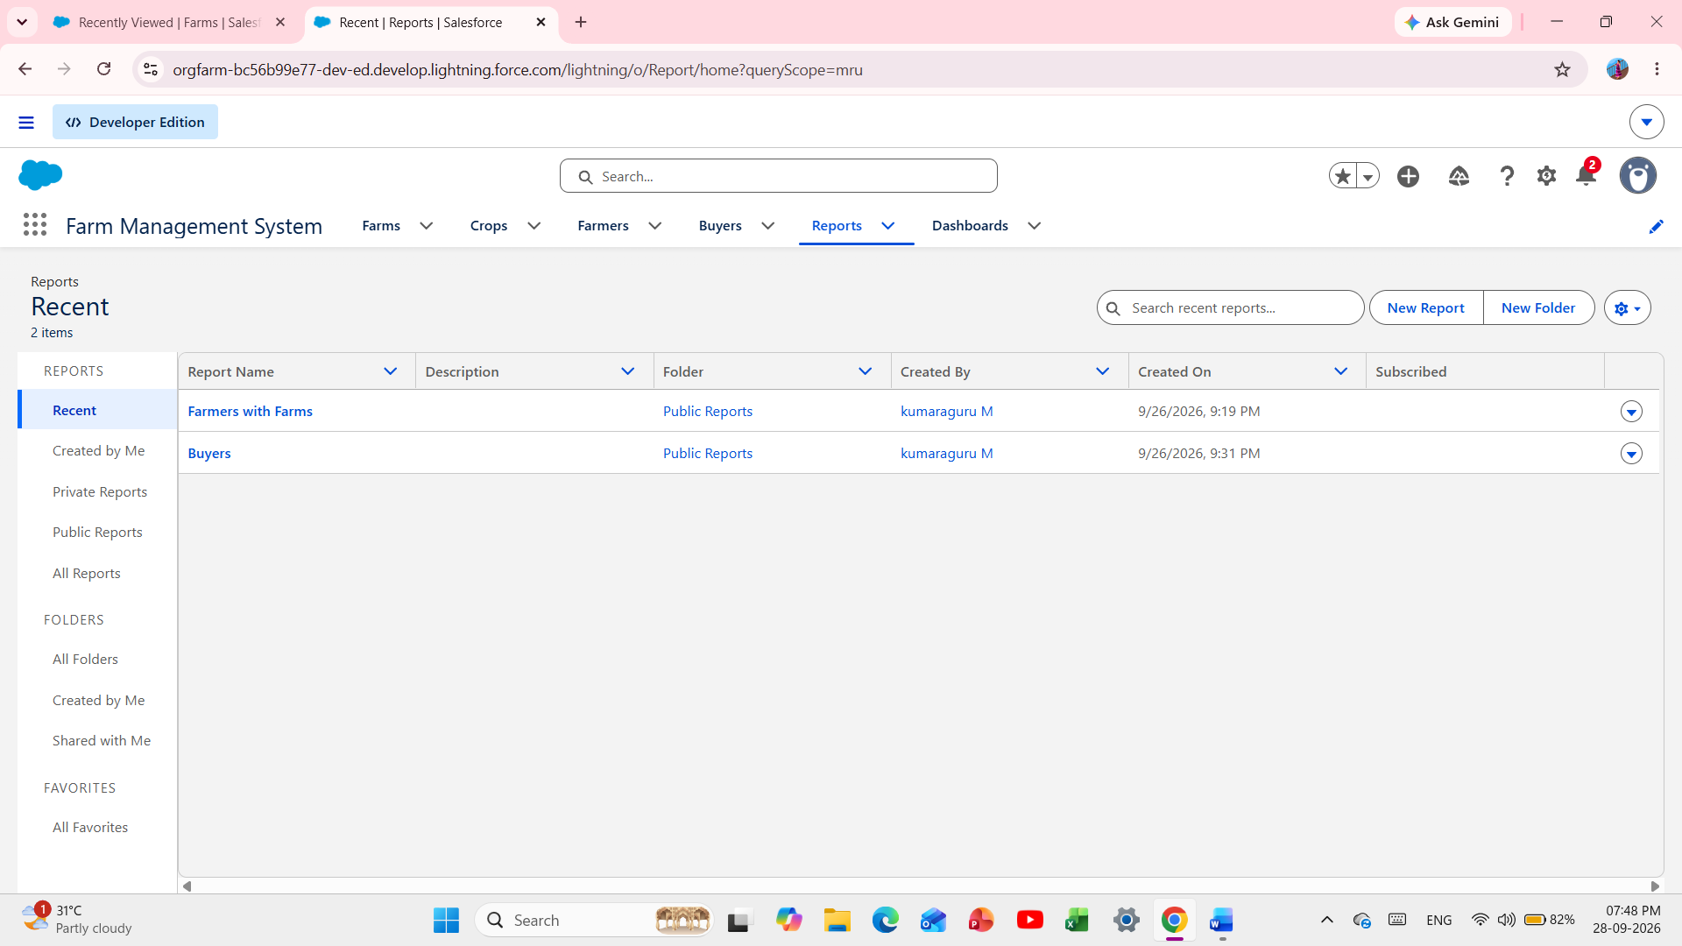

Fig 18 - Report View

Activity 2: Dashboard

- Click App Launcher on the left side of the screen.
- Search Farm Management System and open it.
- Click the Dashboards tab and open the required dashboard.

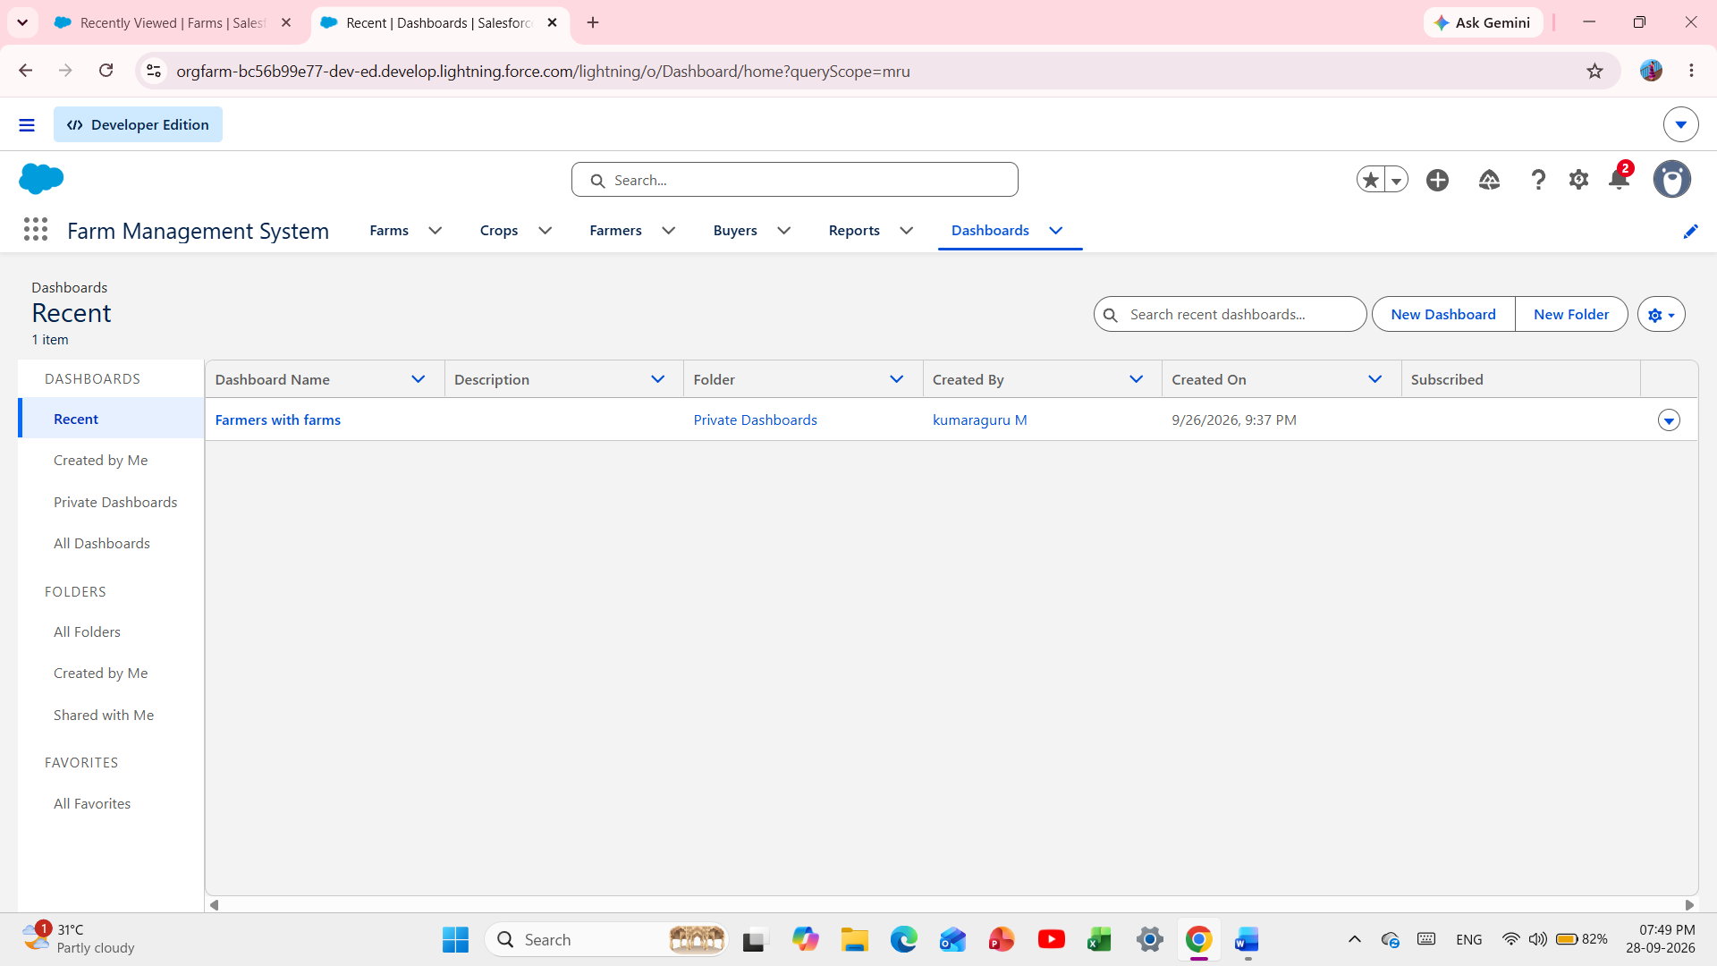

Fig 19 - Dashboard View

- CONCLUSION

- The Farm Management System developed on the Salesforce platform provides an efficient and automated solution for managing agricultural activities. The system successfully integrates key entities such as Farmer, Farm, Crop, and Buyer into a single centralized platform.

- By implementing automation through Record-Triggered Flows like Crop_Update_Flow and Buyer_Notification_Flow, the system ensures real-time updates and timely communication. Validation rules and custom relationships maintain data integrity and accuracy.

- This project proves that Salesforce CRM can be effectively adapted for the agriculture domain to reduce manual work, improve coordination between farmers and buyers, and provide valuable insights through reports and dashboards. The system is scalable and can be further enhanced with features like weather integration, payment management, and mobile application support.

7.1 ADVANTAGES

- Centralized Data Management - All information related to farmers, farms, crops, and buyers is stored in one secure platform.
- Process Automation - Automatic task creation upon buyer creation ensures quick follow-up without manual intervention.
- Effective Crop Monitoring - Automated tracking of crop stages and updates improves farm productivity.
- Enhanced Communication - Instant notifications strengthen the relationship between farmers and buyers.
- User-Friendly Interface - The Lightning interface is intuitive and easy to operate.
- Reporting and Analytics - Custom reports and dashboards help in decision making and performance analysis.
- High Data Security - Salesforce provides robust security, data backup, and access control.
- Scalability - The system can be easily expanded with additional modules as per future requirements.

7.2 DISADVANTAGES

- Internet Dependency - The system requires a continuous internet connection to function.
- High Cost - Salesforce licensing costs may be high for small-scale farmers.
- Training Required - Initial training is necessary for users unfamiliar with Salesforce.
- No Offline Support - The system cannot be accessed in offline mode in remote agricultural areas.
- Limited Custom Logic - Complex agricultural calculations may require additional Apex coding beyond flows.
- Platform Dependency - The system is dependent on Salesforce platform limitations and updates.

APPENDIX

Item | Details
Source Code | Salesforce Configuration (Flows, Objects, Validation Rules)
Dataset | Salesforce Custom Objects
Developer Org | lovelyprince1307.fc033a3a405d@agentforce.com
Team Members | 2 Members
Project Type | Salesforce Administrator with Automation
Prepared By | Kumaraguru. M, Arignar Anna Arts College
Date | September 2026

THANK YOU

